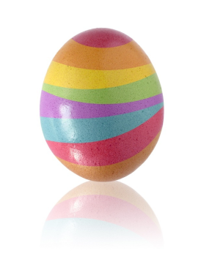
Chemistry “Eggs”periment with Ind “egg”ators

Activity: Dying hard-boiled eggs using chemical indicators
Time: 20-30 minutes
Materials: Hard-boiled eggs
Assortment of acid-base indicators (universal indicator, phenolphthalein, etc.)
Water
Vinegar
Baking Soda
Acids and bases with varying pH

Background:
As a child, I can remember my mom helping me dye eggs around Easter time. We never bought the fancy tablets or packets of materials. We always used food coloring along with a splash of vinegar in our dye solution. I never really considered why that was until I became a chemistry teacher.

As far as I have been able to tell, the egg-dying process is a lesson in polarity as well as acids and bases. As a person who likes to experiment, I tried a few things with my “test eggs” before looking anything up. I tried dying eggs in straight vinegar and food coloring. The color was very bright but when I touched the egg, the shell flaked right off. I remembered that the shell of an egg is made of calcium carbonate. With the vinegar, this causes a reaction that releases carbon dioxide bubbles, which can be seen forming on the surface of the egg. Why didn’t my color stick to the egg? Did the bubbles get in the way?
In fact, there is another part to an egg shell of which I was not aware. Upon researching a bit, I found that the egg shell is protected by a very thin layer of protein molecules called the cuticle. This cuticle is neutral so not much is attracted to it. I found out that food coloring has a negative charge, so to get the dye to “stick” to the cuticle, you have to make the cuticle positively charged. This is why we use vinegar, a weak acid, to dye eggs. It causes the cuticle to become positive and the negative dye is attracted.

This is a great lesson in polarity but a few years back, some of my students took it a bit farther. They decided they wanted to dye their eggs with acid/base indicator. I had never done this before, and that is what made it fun. We made our vinegar solution and chose phenolphthalein. We left the egg in the mixture for about 5 minutes and then removed it and let it dry. We mixed up a solution of weak base (probably baking soda because we always have that on hand) and dripped it on the egg. The color change was amazing. Since then, we have tried other indicators and they work pretty well, especially universal indicator. This is a fun lab to just “play” and see what kind of designs you can come up with.

Materials:
    - Hard boiled eggs
    - Chemical indicators
    - Vinegar
    - Water
    - Other acids and bases (to produce color change)

